Cyber-Ethnography: Part Two – The Power of Fanart Practices in
“Cừu Có Cánh của Captain Boy” or “Captain Boy's Winged Sheep” Facebook group
Course: Digital Anthropology

The video link is HERE.

Introduction
What do you think when you see these images? Do you guess that it is a child, or a baby?
Wait! The result is so surprising, and interesting.
These images are about a rising young singer and rapper in Vietnam called Captain Boy, shared in a facebook group named “Cừu Có Cánh của Captain Boy” (“Winged Sheep of Captain Boy”). With more than 200 thousand members, this Facebook group serves as an online platform for Captain Boy’s fan community to connect, share their admiration, and stay updated on his life.
Scrolling down the group, there are various artworks made and posted by members of this online community, called “fanart”, in such a “cute” way with big eyes, oversized head, tiny hands and feet, and a baby-like appearance, which resembles the kawaii cuteness popular in Japanese anime and manga (Nittono, 2012). Under these fanart posts, there are often many comments complimenting the cuteness of Captain Boy which brings up my first impression of Captain Boy that he is very “cute” despite having not met him in reality. This makes me wonder how the fans present Captain Boy in their artworks, and whether the idea of Captain Boy that I or anyone, who hasn't known him before, gets after seeing this group is his real self-presentation, or the representation made by the fan community through this online Facebook space.
This cyber ethnography will investigate the practices of fanart in “Cừu có cánh của Captain Boy” Facebook group as well as its power on this online community and even offline world. My main argument is:
Fanart practices in this online community act as a form of the Doll cuteness and mediascapes in kawaii aesthetics to reproduce Captain Boy’s image and influence public perception of him on both online and offline spaces.

Literature Review
Let’s move on to the Literature Review with three key theoretical frameworks: the Doll cuteness by Abidin, the mediascapes by Appadurai, and the Online/Online by Miller.
According to Abidin in “Agentic Cute”, the influencers employ three modes of agentic cute named the Doll, the Dear, and the Darling, obscuring a particular soft power on the audience to maintain their viewership and support their business (Abidin, 2016). In Captain Boy’s fanart, this cuteness can be seen as the Doll, “characterized by a visually infantile cuteness”, with babyish features such as “a large head compared to the size of the body, large eyes, round and protruding cheeks” (Abidin, 2016, p. 37). For Abidin, this cute type evokes the affection and protection, sometimes sexual desirability of the audience, which can be used to analyze the influence through Captain Boy’s fanart in this community.
In the book “Disjuncture and Difference”, Appadurai indicated the global cultural flows with five fluid dimensions: ethnoscapes, mediascapes, technoscapes, financescapes, ideoscapes. In which, the mediascapes refer to “the distribution of the electronic capabilities to produce and disseminate information … created by these media.” (Appadurai, 1990, p.35). Mediascapes transcend international borders, bringing the media products from one country to viewers throughout the world. In the context of Captain Boy’s fan group, this concept helps explain why fanarts adopt the visual style of Japanese kawaii cuteness, despite existing within a Vietnamese social and cultural context.
About Miller, he believed that online and offline lives are not separate worlds but deeply intertwined and mutually constitutive. Miller finds that people use digital platforms such as Facebook, Instagram, and Snapchat to maintain family ties, express affection, or signal identity, all in ways that make sense in their specific local culture (Miller, 2015). Understanding this blurred division and the real-world consequences from online actions will help to examine the influence of fanart practices not only in this online community but the real world.

Methods
In addition to foundational theories, this cyber ethnography primarily employs the methods of lurking, the continuous observation in online space without active engagement or participation. Scrolling through the posts, I focus most on the visual elements of each post, along with the captions, and the account who posted. Beyond the content, I specifically examine in detail the interactions under each post, including the number of reactions, comments, shares. The comment sections are another central focus of my analysis, as they reveal how group members interpret and respond to the posts. The language used, the emotional tone provides precise evidence for my analysis. In the scope of this study, I concentrate mainly on fanart posts rather than other types, as the practice and influence of fanart among this online community are the core of my questions and arguments.
The main contents I will observe and analyze are:
- The practices of fanart with the use of “the Doll” cuteness characteristics and as the form of mediascapes.
- The influence of fanart on public perception of Captain Boy within this online community through member interactions and engagement with fanart posts and in the offline world.

Ethnographic Description & Analysis
First, we will investigate the practices of fanart through the lens of “the Doll” cuteness. Throughout the group, various fanart posts can be found. It may be the illustration of one real image of the idol, with a real photo on one side, and a reproduced artwork on the other side.
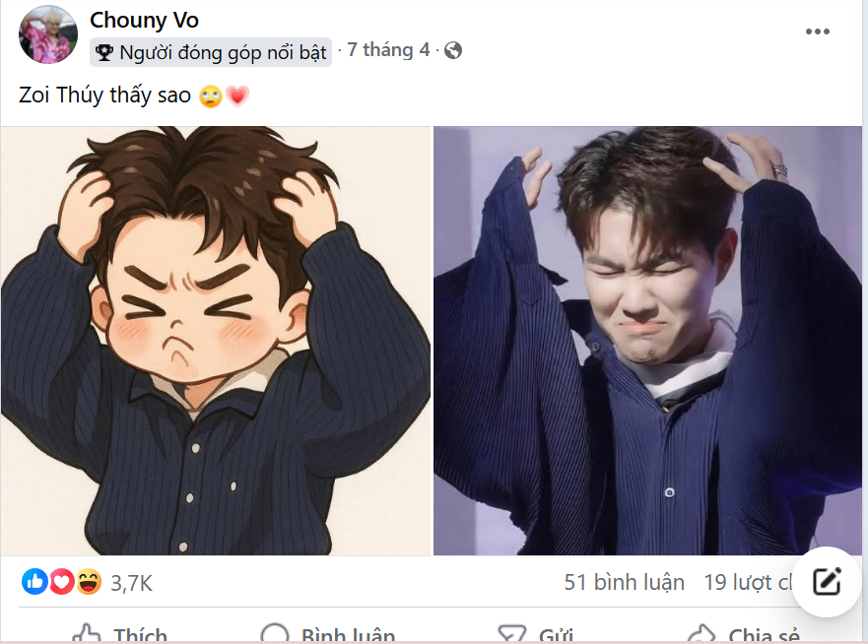
Or, it is the independent creativity of a fan without any real photo provided, delivered with or without a specific message in the image.
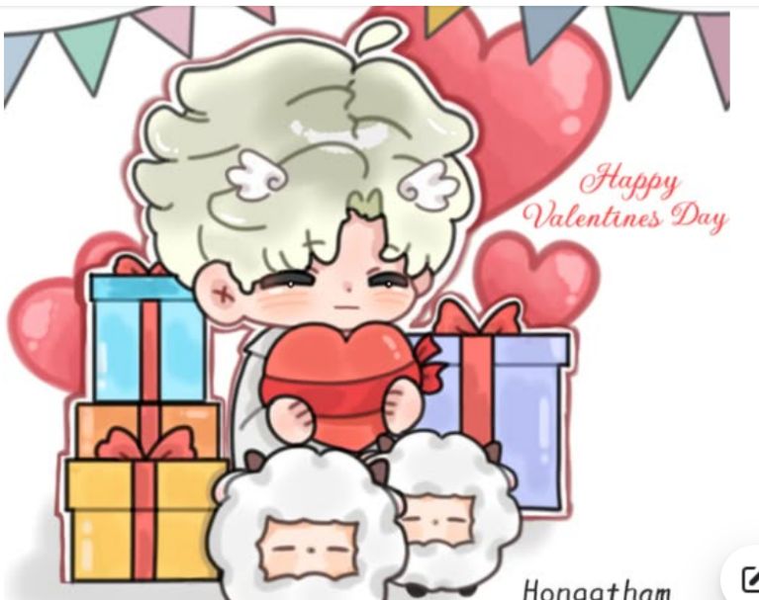
Given any kind of fanart delivery, the common characteristics of them are the babyish appearance, with an oversized head compared to the body proportions, large round sparkling eyes, rosy and chubby cheeks, plump arms and legs, body outlines often drawn with curves and circles, and a face with multiple expressions such as pouting, smiling, or showing surprise. These features evoke associations with a child, baby, infant, or young animal, and are commonly known as elements of kawaii cuteness frequently seen in Japanese manga and anime. Interestingly, the fanart often places Captain Boy surrounded by sheep. As the group name “Winged Sheep of Captain Boy” suggests, the presence of sheep and their playful interactions with Captain Boy in these artworks intentionally represent the close connection between the idol and his fan community.
Applying three types of cuteness by Abidin, these fanarts can be considered as “the Doll”, because they share the same features of the infantile cuteness. Moreover, for Abidin, these cute characteristics play the strategic role for influencers, as they evoke the affective and protective feeling from the audience toward the influencer. Through the lens of “the Doll”, these fanarts not only serve as a mere creativity and reproduction of Captain Boy’s image made by fans but also hidden the soft power that attracts the attention, evokes affection and protection over him, which help him appeal to more followers or fans' interest and support.
The practices of fanart can also be seen as a form of mediascape in the cultural global flow according to Appadurai. Besides considering the artworks’ aesthetics as the Doll cuteness, they are widely known as the kawaii cuteness, which originated in Japan and often use the infantile elements to elicit the affective feelings. Within the flow of media products, various forms of Japanese anime and character goods, such as Pokémon and Hello Kitty, have transcended the international borders and entered Vietnam society, embedded and adapted to local Vietnamese culture, becoming widely used by Vietnamese people. In the case of Captain Boy's group, the practices of creating fanart in the kawaii cuteness style can be seen as evidence of the mediascape flow, where Japanese culture is imported and used as a tool to attract public affection toward an idol within the Vietnamese context.
Move to the interaction and response of the community toward fanart posts.
Overall, most fanart posts in this group receive more than 1000 reactions, mostly “love”, “like”, and “haha”, which indicates feelings of affection and joy when viewing them. A more insightful data point is the comment section under each post. Typically, the comments include requests such as “cho xin ảnh nha” (please share the image with me), compliments on the artist’s drawing skills, or expressions of admiration for Captain Boy’s cuteness using many adjectives like “cưng” (adorable), “dễ thương” (cute), “xinh iu” (lovely), and “em bé” (baby-like). The responses from other members of this online community clearly show their excitement for the fanart, with some even offering to buy it. Moreover, the use of various adjectives to praise Captain Boy’s cuteness is interesting, as it not only reflects individual perceptions, but also contributes to shaping a shared belief that Captain Boy is truly adorable. I refer to this as a form of collective perception, where collective commentary can influence new or unfamiliar members to form a positive impression of Captain Boy based solely on these images, even if they have never met him in real life.
Going beyond the scope of this online community, the concept Online/Offline can help to analyze the influence of these online practices in the offline world. For Miller, the division between online and offline spaces is blurred and the offline is an extension of the online world, where digital activities help sustain real-life relationships such as family ties, friendships, and even the bond between fans and their idols. In this case, fans creating fanart and posting it in a space where Captain Boy is the admin, helps strengthen their connection in online space. This can translate into real-world engagement where members attend Captain Boy’s live shows then post real photos and videos on this group, demonstrating their offline support and presence.
Moreover, the way fanart influences newcomers' impressions of Captain Boy suggests that these online practices foster emotional connections even before any offline interaction occurs. These virtual bonds can lead to offline consequences, such as new members deciding to attend his live shows and build a real connection with him. In this sense, the group’s fanart practices intentionally expand Captain Boy’s audience, using fanarts as a form of outreach and community-building.

Conclusion
In conclusion, this cyber ethnography offers a new perspective on the practices of fanart in the “Cừu có cánh của Captain Boy” Facebook group. From an aesthetic viewpoint, the concept of “the Doll” cuteness and the mediascapes of kawaii culture in Vietnam reveals a strategy behind these fanarts to evoke feelings of affection, admiration, and protection within the community, even among those who have never met Captain Boy offline. Moreover, the interactions and responses under fanart posts become a tool for expanding his audience and encouraging fans to engage with him in real life. This case demonstrates the power of an online fan activity in shaping a celebrity’s image and generating significant influence in both online and offline spaces.

References
Abidin, C. (2016). Agentic cute (^.^): Pastiching East Asian cute in Influencer commerce. East Asian Journal of Popular Culture, 2(1), 33–47. https://doi.org/10.1386/eapc.2.1.33_1
Appadurai, A. (1990). Disjuncture and difference in the global cultural economy. Theory, Culture & Society, 7(2-3), 295–310. https://doi.org/10.1177/026327690007002017
Miller, D. (2015). Photography in the age of Snapchat. Royal Anthropological Institute.
Nittono, H., Fukushima, M., Yano, A., & Moriya, H. (2012). The power of kawaii: viewing cute images promotes a careful behavior and narrows attentional focus. PLoS ONE, 7(9), e46362. https://doi.org/10.1371/journal.pone.0046362

